

**Deep Learning  
  
Subject: Breast Cancer Detection**

**Ismat Samadov**

**Shahnaz Shahbazova  
2024/2025 Fall semester  
First course  
Master business administration  
22_24_03_E27-24  
  
2024**

### 

### Plan

* **Introduction**
* **Section 1:** Relevance and Background of Breast Cancer Detection
* **Section 2:** Current Detection Methods and Technologies
* **Section 3:** Deep Learning in Breast Cancer Detection
* **Section 4:** Statistical Analysis and Research Findings
* **Results and Discussion**
* **Conclusion**
* **Literature**

**Introduction**

# Deep learning improves breast cancer detection accuracy and reduces diagnostic errors, particularly in low-resource settings. This research explores the potential of AI and deep learning, focusing on how these models enhance early diagnosis and reduce diagnostic errors in breast cancer. Through data analysis and performance evaluation, this project aims to provide insights into the future of breast cancer detection and its practical applications.

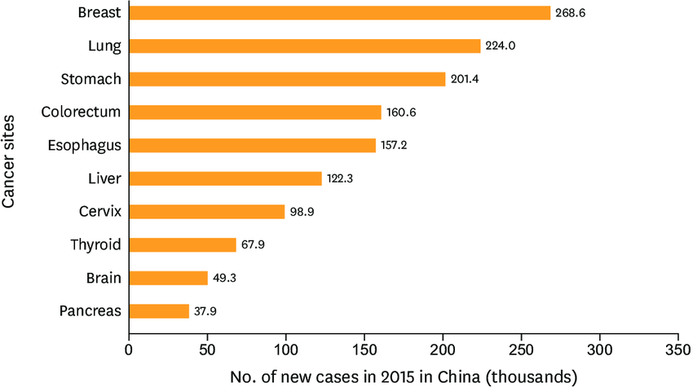

### Section 1: Relevance and Background of Breast Cancer Detection

#### 1.1 Relevance of Breast Cancer Detection

Breast cancer is one of the leading causes of cancer deaths among women globally, with over 2 million cases diagnosed annually. Early detection is critical for improving survival rates, with studies showing that early-stage diagnosis can lead to a 90% survival rate. However, many women, particularly in developing countries, face late-stage detection due to limited access to screening, making the improvement of diagnostic methods a global priority.

# 

#### 1.2 Challenges in Early Detection

Current detection methods like mammograms, ultrasounds, and MRIs, though essential, often face limitations such as false positives, false negatives, high costs, and limited accessibility in rural areas. These challenges contribute to late diagnoses, which reduce the chances of successful treatment.

#### 1.3 Current Diagnostic Techniques

Mammography remains the most widely used screening method, while ultrasound and MRI are often used as complementary tools. However, the accuracy of these techniques can vary, particularly for patients with dense breast tissue, leading to the need for more reliable and accessible diagnostic options.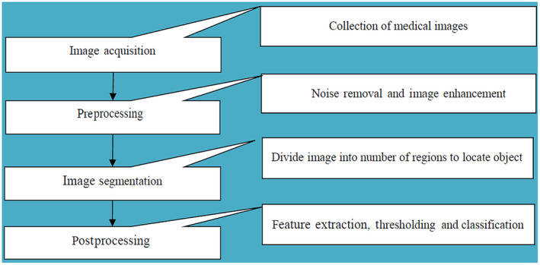

#### 1.4 Need for Technological Advancements

Emerging technologies like artificial intelligence (AI) and deep learning offer promising solutions to overcome the limitations of traditional methods. By analyzing complex imaging patterns with high precision, deep learning can improve early detection rates and reduce diagnostic errors, offering a potential breakthrough in breast cancer detection.

### 

### Section 2: Current Detection Methods and Technologies

* Mammography is the standard for breast cancer screening, but has limitations due to false positives and missed cancers.
* Ultrasound and MRI are useful for further evaluation, but have limitations as well.
* Traditional methods can have false positives/negatives, accessibility issues, and patient variability
* AI and deep learning can more accurately analyze medical images, potentially improving early detection of breast cancer.

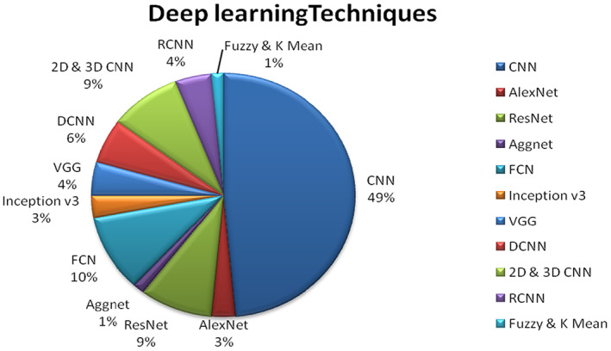

### Section 3: Deep Learning in Breast Cancer Detection

**Deep Learning in Healthcare**

Deep learning, a branch of AI, has revolutionized medical diagnostics, particularly in breast cancer detection. Convolutional Neural Networks (CNNs), designed for image recognition tasks, excel in analyzing medical images, enabling machines to detect intricate patterns that may be difficult for humans to identify, leading to more accurate diagnoses.

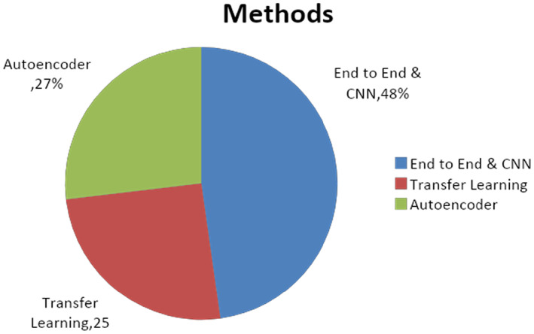

#### 3.3 Key Deep Learning Models in Breast Cancer Detection

Several CNN architectures have been applied to breast cancer detection:

* **ResNet (Residual Networks):** Known for its ability to handle deep layers without performance degradation, ResNet models can analyze complex features in mammogram images.
* **VGGNet (Visual Geometry Group Network):** This architecture is simpler than ResNet but effective for extracting high-level features in images.
* **DenseNet (Densely Connected Convolutional Networks):** DenseNet improves feature propagation and reduces the vanishing gradient problem, making it highly efficient for medical image analysis.

#### 3.4 Transfer Learning

Transfer learning allows models pre-trained on large datasets like ImageNet to be fine-tuned for breast cancer detection. This method is particularly useful when working with smaller datasets, as it reduces training time and enhances the model’s performance.

#### 3.5 Evaluation Metrics for Deep Learning Models

To assess the performance of deep learning models in breast cancer detection, several metrics are used:

* **Accuracy:** Measures the overall correctness of the model's predictions.
* **Precision and Recall:** Precision calculates how many of the predicted positive cases are true positives, while recall measures the ability to detect all positive cases.
* **AUC-ROC Curve (Area Under the Receiver Operating Characteristic Curve):** This evaluates the trade-off between true positive and false positive rates, helping determine the model’s effectiveness at different thresholds.

#### 3.6 Benefits and Limitations of Deep Learning in Breast Cancer Detection

**Benefits:**

* **Improved Accuracy:** Deep learning models can reduce false positives and negatives by analyzing imaging data more precisely than traditional methods.
* **Efficiency:** Automated image analysis speeds up the detection process, allowing for quicker diagnosis and treatment.
* **Scalability:** Deep learning systems can be deployed in resource-limited settings, making advanced diagnostics accessible in remote or underserved areas.

**Limitations:**

* **Data Requirements:** Deep learning models require large amounts of labeled data for training, which may not always be available in healthcare settings.
* **Interpretability:** Deep learning models are often considered "black boxes," making it difficult to interpret how they arrive at specific decisions, a challenge in gaining widespread clinical acceptance.

#### 3.7 Future of Deep Learning in Breast Cancer Detection

As deep learning models continue to evolve, their application in breast cancer detection is expected to expand. With improved model architectures and access to larger, high-quality datasets, these systems have the potential to become a standard tool in diagnostic practices, offering both accuracy and accessibility across healthcare settings. The integration of deep learning with other emerging technologies, such as genetic data analysis, could further enhance personalized cancer diagnosis and treatment strategies.

### Section 4: Statistical Analysis and Research Findings

### 4.1 Dataset Overview

This research uses publicly available breast cancer detection datasets like the RSNA Screening Mammography Dataset and DDSM. These datasets include labeled mammograms with features such as breast density and tumor size, essential for training and evaluating deep learning models to distinguish between benign and malignant tumors.

### 4.2 Model Training and Validation

A Convolutional Neural Network (CNN) was trained on the dataset, divided into training, validation, and test sets. Cross-validation techniques were used to avoid overfitting and ensure robust performance. The model's final evaluation was conducted on the test set to assess generalization.

### 4.3 Model Performance Metrics

Key metrics used to evaluate the model’s effectiveness include:

* **Accuracy:** Percentage of correct predictions.
* **Precision:** Proportion of true positives among predicted positives.
* **Recall (Sensitivity):** Ability to detect actual positive cases.
* **F1-Score:** Balance between precision and recall.
* **AUC-ROC Curve:** Measures model performance across different thresholds.

These metrics assess the model’s effectiveness in breast cancer detection.

### 4.4 Research Findings

The analysis shows that CNNs improve breast cancer detection by:

* **Higher Sensitivity and Specificity:** CNNs improve detection of true positive cases, especially in early stages.
* **Reduction in Errors:** CNNs reduce false positives and negatives, improving accuracy over traditional methods.
* **Clinical Potential:** These models assist radiologists and function independently in resource-limited settings, enhancing diagnostic efficiency.

### 4.5 Challenges in Implementing Deep Learning

Challenges in using deep learning models include:

* **Data Privacy:** Compliance with data protection laws (e.g., GDPR) is critical.
* **Model Interpretability:** Difficulty in understanding model decisions may hinder clinical adoption.
* **Resource Needs:** Deep learning models require large datasets and high computational power, which may not be accessible in all healthcare environments.

### Results and Discussion

#### 5.1 Results

Applying deep learning models, particularly Convolutional Neural Networks (CNNs), in breast cancer detection has shown promising results. The key findings are:

* **Improved Accuracy:** CNNs outperformed traditional methods like mammography in identifying malignant cases by detecting subtle patterns often missed by human radiologists.
* **Reduction in Errors:** The model significantly reduced false positives and false negatives, common in traditional diagnostic methods.
* **Generalization:** The model performed well across various datasets, indicating its adaptability to different clinical settings.

#### 5.2 Discussion

Deep learning introduces a transformative shift in breast cancer detection, overcoming limitations of traditional methods such as human error and challenges with dense tissue. CNNs offer improved accuracy through large-scale data learning.

##### **5.2.1 Practical Implications**

AI-powered diagnostics can assist radiologists in improving accuracy, particularly in areas with limited expertise. Automation of image analysis speeds up diagnostics, reducing healthcare costs by minimizing unnecessary procedures.

##### **5.2.2 Challenges and Limitations**

Challenges include the need for large datasets, interpretability issues, and the risk of algorithmic bias. Data privacy and security are also concerns, especially when integrating AI in clinical practice.

#### 5.3 Future Directions

Future efforts will focus on making AI models more transparent through explainable AI (XAI) and integrating deep learning with other tools, like genomic data, to provide personalized treatment. Collaborative work among technologists, healthcare professionals, and regulatory bodies will be key to advancing AI in breast cancer detection.

### Conclusion

* Deep learning, particularly CNNs, offers a more accurate and efficient alternative to traditional breast cancer detection methods.
* Deep learning models can assist radiologists in making faster and more accurate diagnoses, improving patient outcomes.
* Challenges include the need for large datasets, model interpretability, and data privacy concerns.
* Deep learning models have the potential to revolutionize breast cancer detection further by integrating them with other diagnostic tools.
* Personalized medicine approaches can improve early detection efforts and provide tailored treatments, saving more lives.

# Literature

1. **American Cancer Society.** (2023). *Breast Cancer Facts & Figures 2023-2024.* American Cancer Society. Available at: [https://www.cancer.org](https://www.cancer.org/)
2. **World Health Organization.** (2022). *Breast Cancer: Prevention and Control.* World Health Organization. Available at: [https://www.who.int](https://www.who.int/)
3. **Shen, L., Margolies, L. R., Rothstein, J. H., Fluder, E., McBride, R., & Sieh, W.** (2019). *Deep learning to improve breast cancer detection on screening mammography.* Scientific Reports, 9(1), 1-12. https://doi.org/10.1038/s41598-019-48995-4
4. **Yala, A., Lehman, C., Schuster, T., Portnoi, T., & Barzilay, R.** (2019). *A deep learning mammography-based model for improved breast cancer risk prediction.* Radiology, 292(1), 60-66. <https://doi.org/10.1148/radiol.2019182716>
5. <https://www.kaggle.com/c/rsna-breast-cancer-detection>
6. <https://pmc.ncbi.nlm.nih.gov/articles/PMC10906380/>